**Objective:** During this session, the focus was on familiarizing yourself with Trello, encompassing tasks such as initiating and configuring Trello, exploring its interface, setting up a new project on the dashboard, and acquainting myself with its diverse features.

**Tasks:**

**1. Starting and Setting up Trello:**

* Trello was accessed via the web browser since the desktop application was not available.
* The initial steps involved signing into the existing Trello account or creating a new one, followed by configuring profile settings and preferences to align with individual requirements.

**2. Exploring the Toolbars:**

* A comprehensive exploration of the various toolbars and menus within the Trello interface was undertaken.
* Identification of key functionalities such as boards, lists, cards, and search capabilities were emphasized.
* Additional tools and integrations were noted, considering the version of Trello utilized.

**3. Creating a New Project on the Dashboard:**

* The process of initiating a new project or board on the Trello dashboard was executed seamlessly.
* Attention was given to providing an apt name for the project along with a concise description for contextual clarity.

**4. Familiarizing with Different Features:**

* Dedication of time towards acquainting oneself with the diverse features within the newly established project was prioritized.
* Experimentation with functionalities such as creating lists and cards facilitated effective organization of tasks and ideas.
* Particular emphasis was placed on features including labels, due dates, attachments, and comments, essential for fostering collaboration and organization.
* Further customization of the project was explored through the exploration of additional settings and options available.

**Conclusion:** The tasks outlined in Session 1 were successfully accomplished, contributing to a comprehensive understanding of Trello's foundational aspects. Going forward, continued practice and exploration will enhance proficiency with the platform. Anticipating forthcoming sessions, where deeper insights into advanced features and productivity strategies will be gained.

**Trello: Getting Started - Session 1**

This session serves as an introduction to Trello, a popular project management tool. We'll explore setting up Trello, understanding its interface, and creating your first project.

**1. Setting Up Trello:**

Trello offers both online and desktop versions. You can access the online version at <https://trello.com/> or download the desktop app for your operating system.

* **Online Version:**
  + Create a free account with your email address or sign in using Google or Apple.
  + Once logged in, you'll land on your dashboard, which is your central hub for accessing all your projects and boards.
* **Desktop Version:**
  + Download and install the Trello app for your system.
  + Launch the app and sign in using your existing Trello account credentials.

**2. Toolbar Tour:**

Both the online and desktop versions share a similar interface with various toolbars aiding navigation and action. Let's familiarize ourselves with some key elements:

* **Top Bar:**
  + Displays your name, notifications, and quick access to settings and account management.
  + You can also search for boards, members, and power-ups (additional functionalities) from here.
* **Board Menu:**
  + Located on the left side of the screen, it houses your list of boards and allows you to create new ones.
* **Card Menu (within a board):**
  + Appears on the right side of the board and provides options for adding new lists, cards, and power-ups specific to that board.
* **Card Actions:**
  + Each card has individual actions like adding checklists, labels, comments, attachments, and due dates.

**3. Creating a New Project:**

From your dashboard, follow these steps to create a new project board:

1. Click on the "Create new board" button.
2. Give your board a descriptive name.
3. Choose "Make it private" if you want only specific members to access it.
4. Click "Create board."

**4. Exploring Trello Features:**

Trello offers various features to manage your projects effectively:

* **Lists:** Represent different stages in your workflow (e.g., To Do, In Progress, Done). You can add, rename, and rearrange lists as needed.
* **Cards:** Represent individual tasks within your project. You can add descriptions, comments, attachments, labels (for categorization), and checklists to each card.
* **Labels:** Colorful tags used to categorize cards for easy visual identification and filtering.
* **Checklists:** Break down larger tasks into smaller, actionable items within a card.
* **Comments:** Facilitate communication and collaboration between team members on specific cards.
* **Attachments:** Allow you to upload relevant files, images, or documents to your cards.
* **Due Dates:** Set deadlines for cards to ensure timely completion of tasks.

This session provided a basic understanding of setting up and navigating Trello. We'll delve deeper into creating and managing projects with advanced features in subsequent sessions.

share

more_vert

**GEMINI RESPONSE WITHOUT IMAGE**

**Trello: Getting Started - Session 1**

This session equips us with the essentials to **set up our Trello accounts, understand the interface, and create our first project**.

**Setting Up Trello:**

Trello is available **both online and as a desktop app**. We can access the online version at <https://trello.com/> or download the app for our operating systems.

**Online Version:**

1. **Create a free account** using our email addresses or sign in conveniently with Google or Apple.
2. Upon logging in, we'll land on our **dashboards**, the central hubs for accessing and managing all our projects and boards.

**Desktop Version:**

1. **Download and install** the Trello app for our systems.
2. **Launch the app** and sign in using our existing Trello account credentials.

**Navigating the Interface:**

Both interfaces share a similar layout with intuitive toolbars for easy navigation. Let's explore some key elements:

* **Top Bar:** This bar displays our names, notifications, and provides quick access to settings and account management. We can also search for specific boards, members, or power-ups (additional functionalities) from here.
* **Board Menu:** Located on the left side of the screen, this menu houses our existing boards and allows us to **create new ones** to organize our projects effectively.
* **Card Menu (within a board):** This menu appears on the right side of the board and provides options for adding new lists, cards, and power-ups specific to that board, enabling us to customize our workflows.
* **Card Actions:** Each card, representing individual tasks within our projects, has its own set of actions. We can add checklists for breaking down complex tasks, labels for categorization, comments for team collaboration, attachments like files or images for reference, and due dates to ensure timely completion.

**Creating Our First Project:**

Excited to dive into our first projects? From our dashboards, follow these simple steps:

1. Click on the inviting "**Create new board**" button.
2. Give our boards **descriptive names** that reflect the projects' purposes, making them easy to identify and reference later.
3. Choose the "**Make it private**" option if we only want specific members to access and collaborate on the projects.
4. Click "**Create board**" to bring our projects to life on Trello.

**Exploring Trello's Features:**

Trello offers various features to manage our projects effectively:

* **Lists:** These represent different stages in our workflows, allowing us to visualize the progress of our tasks. We can add lists like "To Do," "In Progress," and "Done," and easily rename or rearrange them to suit our specific needs.
* **Cards:** Each card represents an individual task within our projects. We can add detailed descriptions, insightful comments for team discussions, relevant attachments, and helpful checklists to break down larger tasks into manageable steps, ensuring clarity and efficient execution.
* **Labels:** These colorful tags act as visual cues, allowing us to categorize cards for easy identification and filtering. Assign labels to prioritize tasks, highlight specific types of tasks, or categorize them based on different criteria.
* **Checklists:** Feeling overwhelmed by a large task? Break it down into smaller, actionable items within a card using checklists. This helps us stay focused, track progress, and achieve the larger goal efficiently.
* **Comments:** Foster communication and collaboration within our teams by adding comments directly on specific cards. Discuss ideas, ask questions, provide updates, and keep everyone informed on the projects' progress.
* **Attachments:** Need to refer to a document, image, or other file for a specific task? Simply upload it as an attachment to the relevant card, keeping all essential information readily accessible for our teams.
* **Due Dates:** Set deadlines for cards to ensure timely completion of tasks, keeping our projects on track and meeting objectives.

This session provided a foundational understanding of setting up, navigating, and creating our first projects in Trello. We'll delve deeper into advanced features and explore various functionalities in subsequent sessions to help us become Trello pros!

**Trello: Getting Started - Session 1**

During this session, the focus was on familiarizing yourself with Trello, encompassing tasks such as initiating and configuring Trello, exploring its interface, setting up a new project on the dashboard, and acquainting myself with its diverse features.

**Setting Up Trello:**

Trello is available **both online and as a desktop app**. We can access the online version at <https://trello.com/> or download the app for our operating systems.

**Online Version:**

1. **Create a free account** using our email addresses or sign in conveniently with Google or Apple.
2. Dashboard of Trello
   Upon logging in, we'll land on our **dashboards**, the central hubs for accessing and managing all our projects and boards.

**Desktop Version:**

1. **Download and install** the Trello app for our systems.
2. **Launch the app** and sign in using our existing Trello account credentials.

I used the online version of Trello as it was easy to access and did not take any disk space in my PC. It also saved us from the hassle of the installation on the PC.

**Navigating the Interface:**

Both interfaces share a similar layout with intuitive toolbars for easy navigation. Let's explore some key elements:

* **Top Bar:** This bar displays our names, notifications, and provides quick access to settings and account management. We can also search for specific boards, members, or power-ups (additional functionalities) from here.



* **Board Menu:** Located on the left side of the screen, this menu houses our existing boards and allows us to **create new ones** to organize our projects effectively.

* **Card Menu (within a board):** This menu appears on the right side of the board and provides options for adding new lists, cards, and power-ups specific to that board, enabling us to customize our workflows.

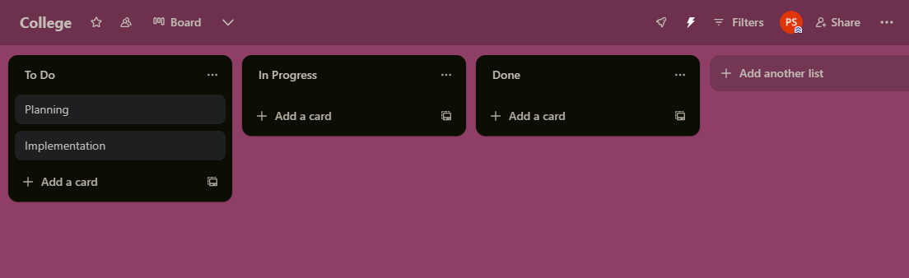

* **Card Actions:** Each card, representing individual tasks within our projects, has its own set of actions. We can add checklists for breaking down complex tasks, labels for categorization, comments for team collaboration, attachments like files or images for reference, and due dates to ensure timely completion.

**Creating Our First Project:**

1. Click on the "**Create new board**" button.
2. Give our boards **descriptive names** that reflect the projects' purposes, making them easy to identify and reference later.
3. Choose the "**Make it private**" option if we only want specific members to access and collaborate on the projects.
4. A screenshot of a computer

   Description automatically generatedClick "**Create board**" to bring our projects to life on Trello.

**Exploring Trello's Features:**

Trello offers various features to manage our projects effectively:

* **Lists:** These represent different stages in our workflows, allowing us to visualize the progress of our tasks. We can add lists like "To Do," "In Progress," and "Done," and easily rename or rearrange them to suit our specific needs.

* A screenshot of a computer program

  Description automatically generated**Cards:** Each card represents an individual task within our projects. We can add detailed descriptions, insightful comments for team discussions, relevant attachments, and helpful checklists to break down larger tasks into manageable steps, ensuring clarity and efficient execution.
* **Labels:** These colorful tags act as visual cues, allowing us to categorize cards for easy identification and filtering. Assign labels to prioritize tasks, highlight specific types of tasks, or categorize them based on different criteria.

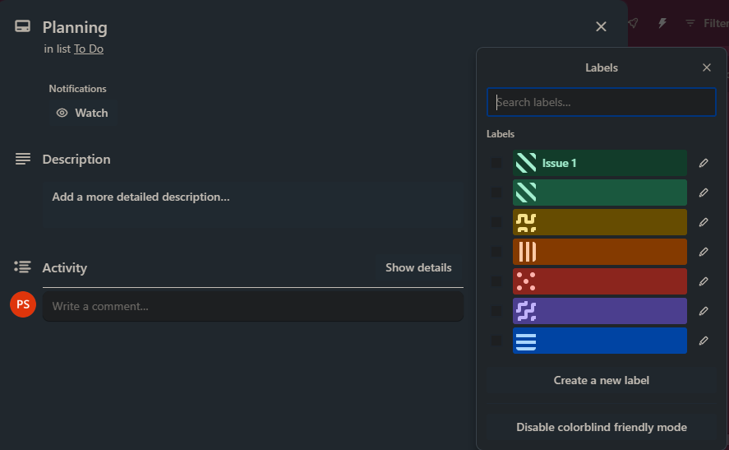

* **Checklists:** We can break a large task into smaller, actionable items within a card using checklists. This helps us stay focused, track progress, and achieve the larger goal efficiently.

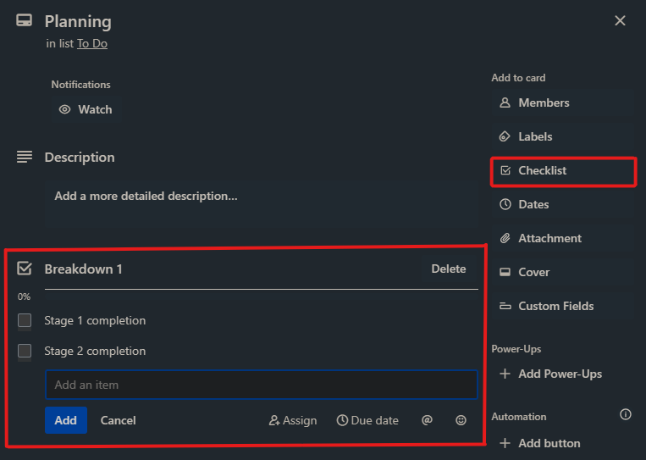

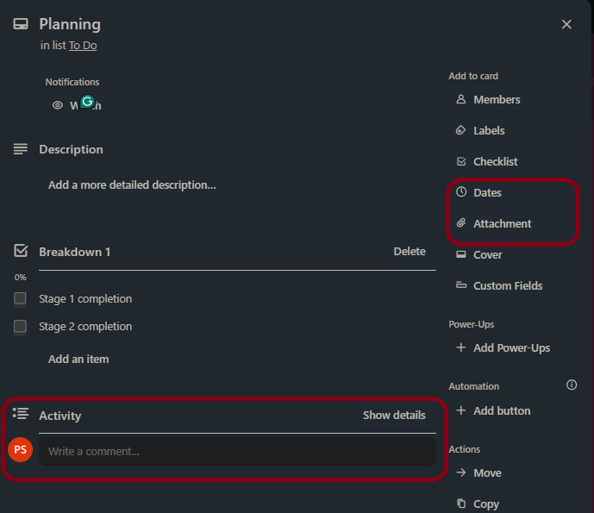

* **Comments:** Foster communication and collaboration within our teams by adding comments directly on specific cards. Discuss ideas, ask questions, provide updates, and keep everyone informed on the projects' progress.
* **Attachments:** Need to refer to a document, image, or other file for a specific task? Simply upload it as an attachment to the relevant card, keeping all essential information readily accessible for our teams.
* **Due Dates:** Set deadlines for cards to ensure timely completion of tasks, keeping our projects on track and meeting objectives.

This session provided a foundational understanding of setting up, navigating, and creating our first projects in Trello. We'll delve deeper into advanced features and explore various functionalities in subsequent sessions to help us become Trello pros!